DAY 4-CSA2075(C PROGRAMMING)

1. Write a program to find the sum of elements in an array using pointers.

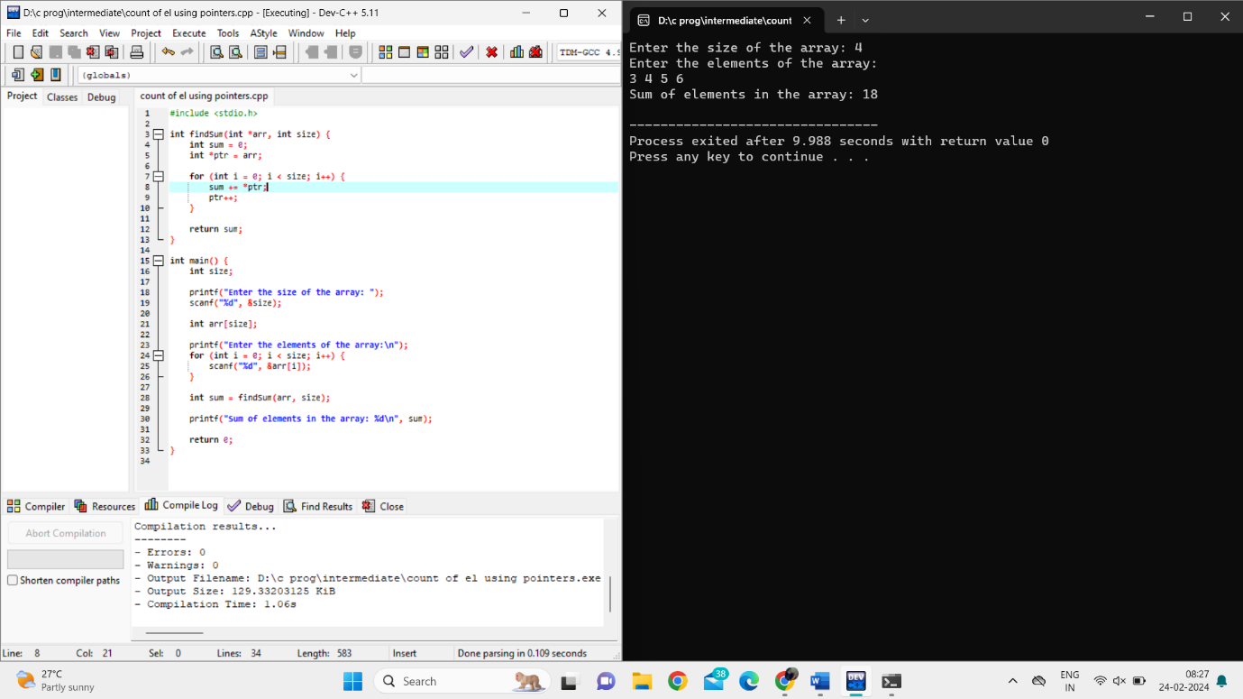

1. Write a program to delete an element from an array using pointers.

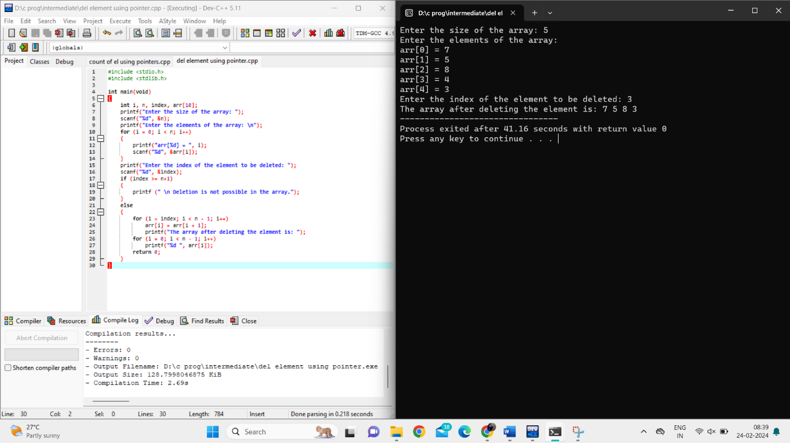

Write a program to reverse an array using pointers.

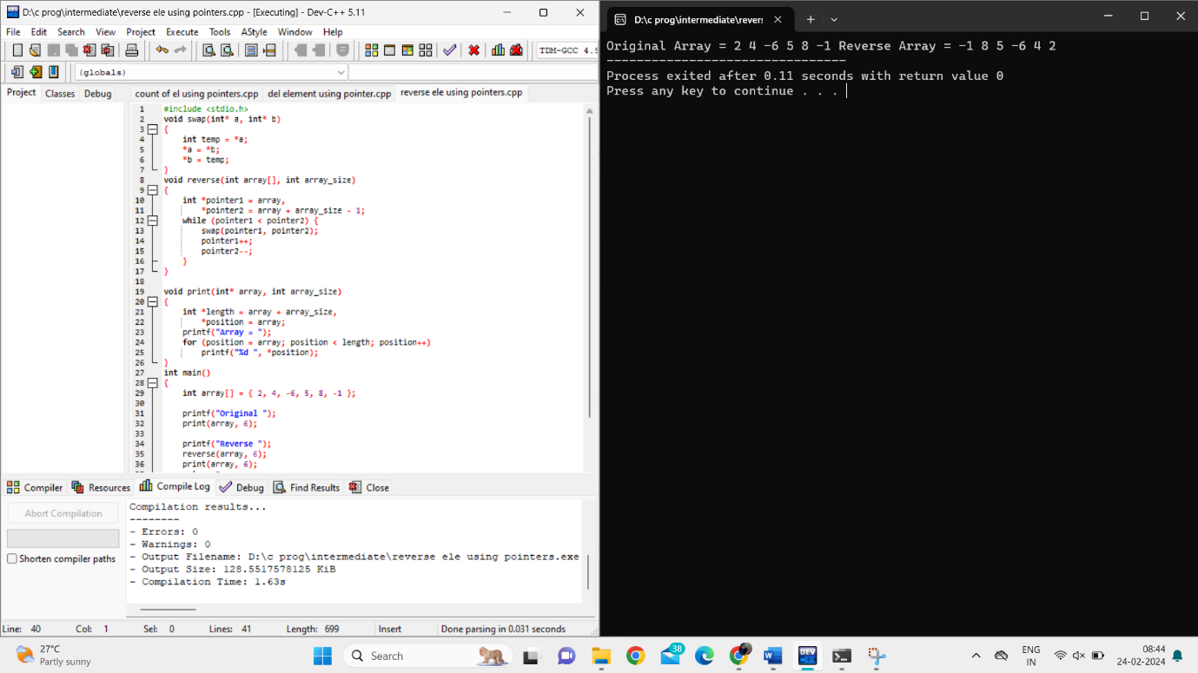

Write a program to find the largest and smallest elements in an array using pointers.

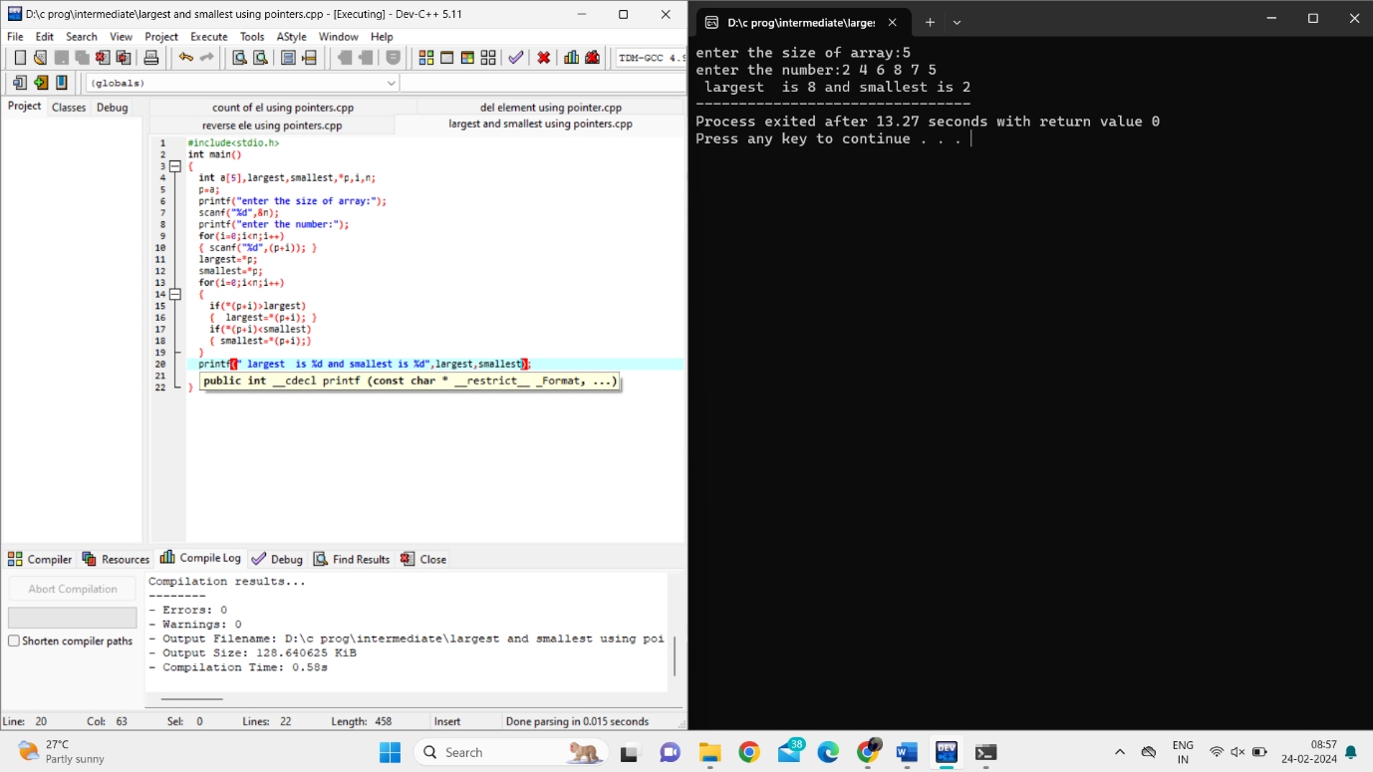

Write a program to copy the contents of one array to another using pointers.

Write a program to find the intersection of two arrays using pointers.

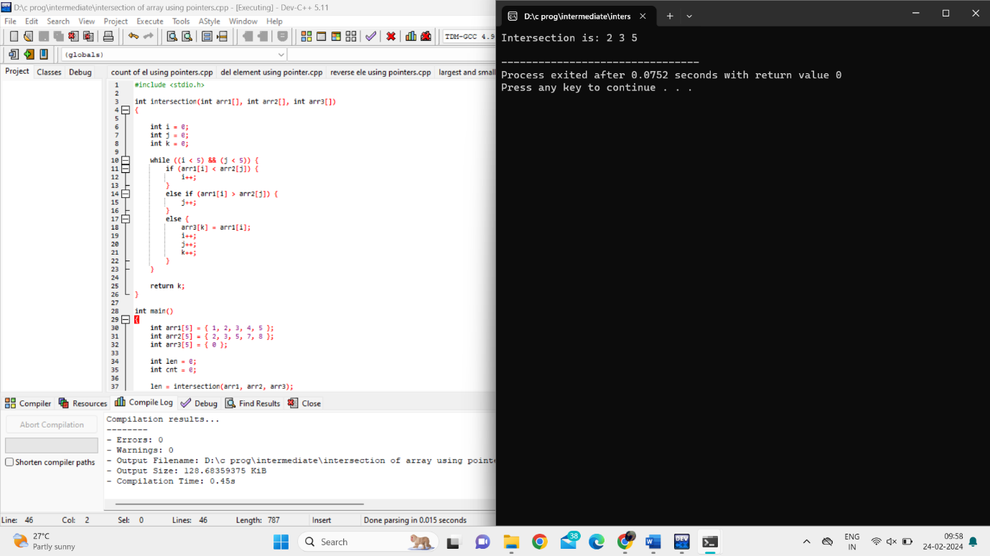

Write a recursive program to calculate the factorial of a given number.

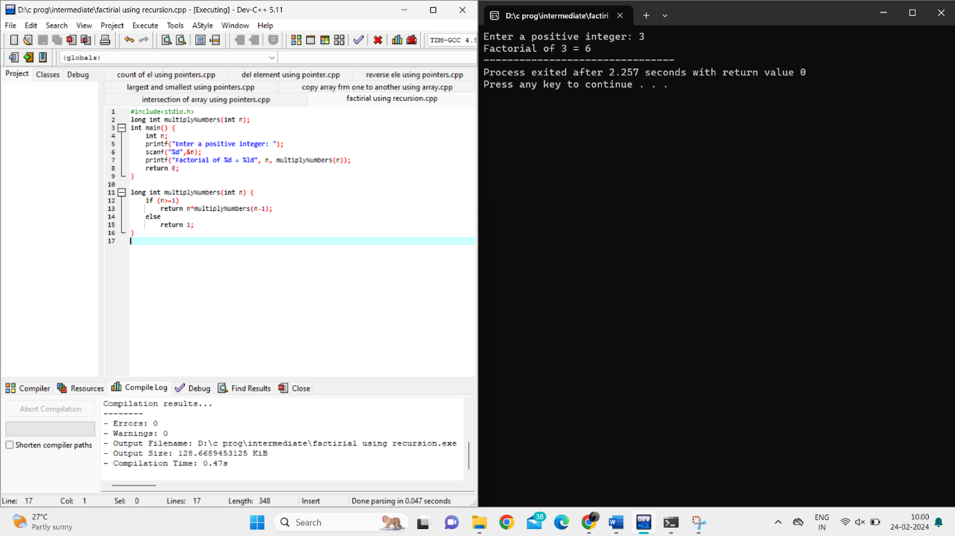

Implement a recursive program to find the nth Fibonacci number.

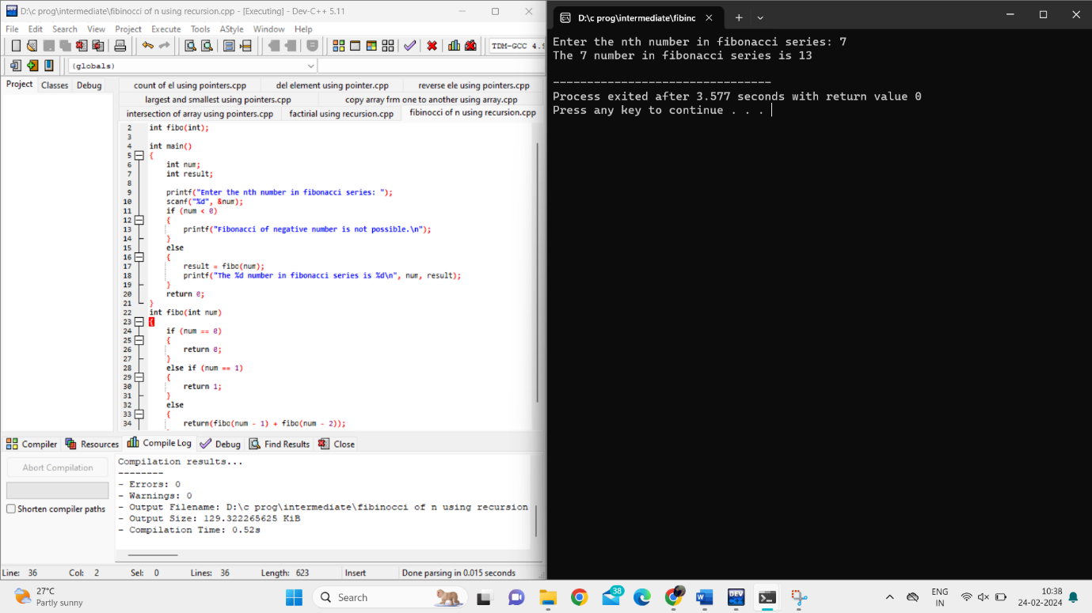

Write a program to recursively calculate the sum of digits in a given number.



Implement a recursive program to calculate the power of a number.

Write a program to recursively calculate the GCD (Greatest Common Divisor) of two numbers.

ANALYTICAL-DAY 4

Area of triangle:

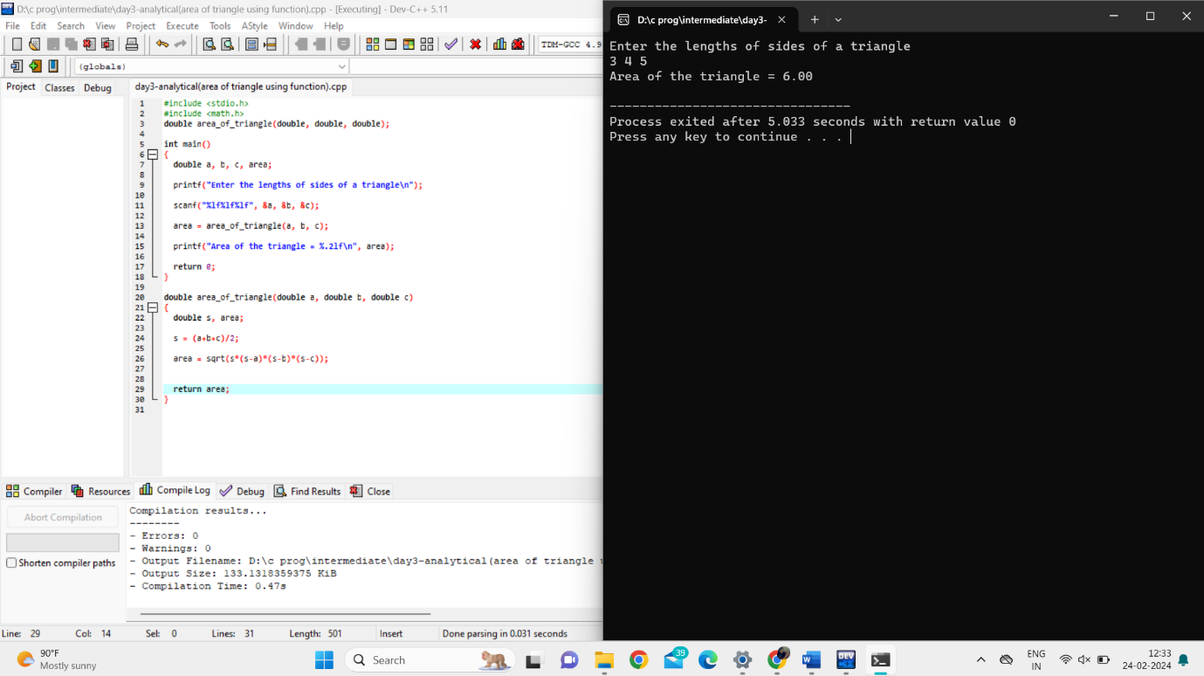

Conversion of temp :

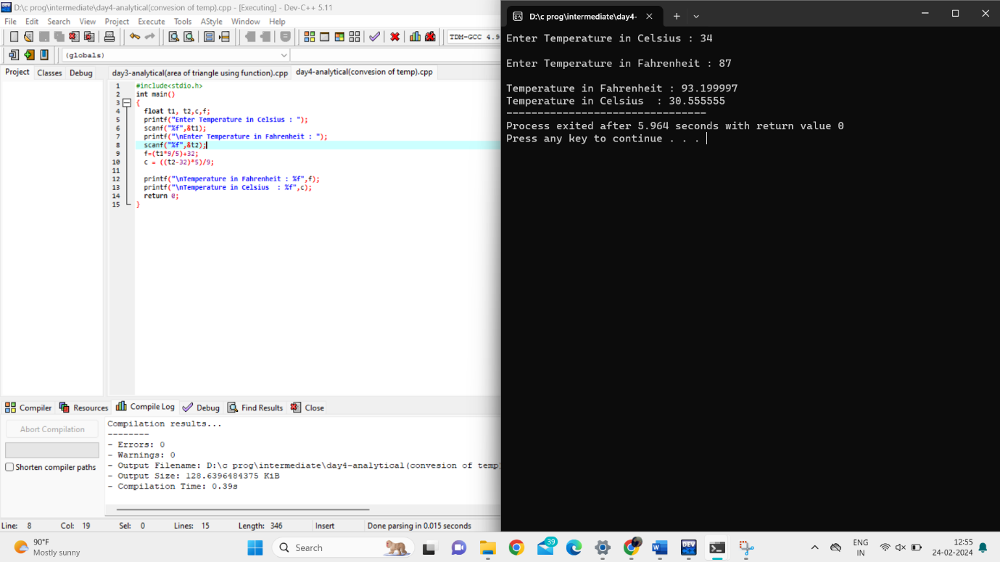

Sum of digits till reduced to single digit:

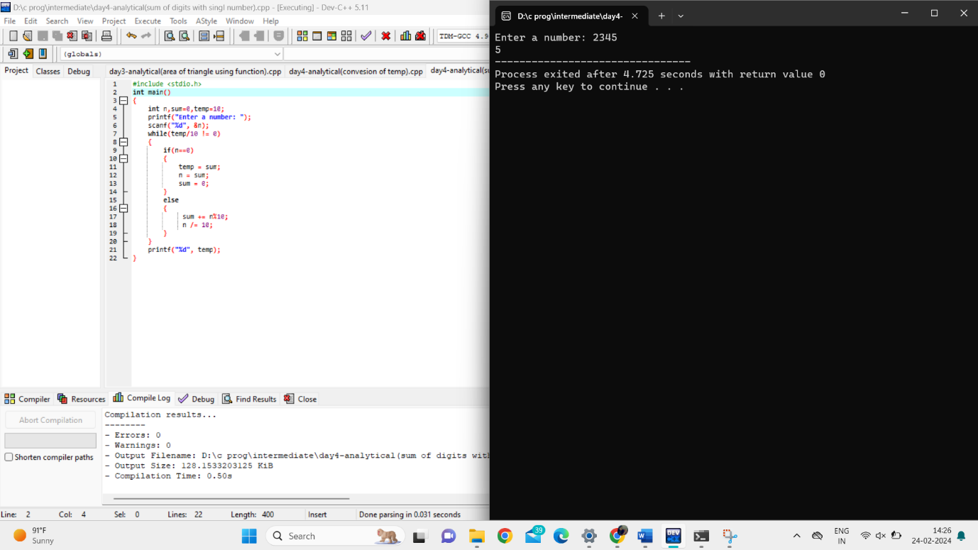

Write a C program to implement a function that checks whether a given year is a leap year or not.

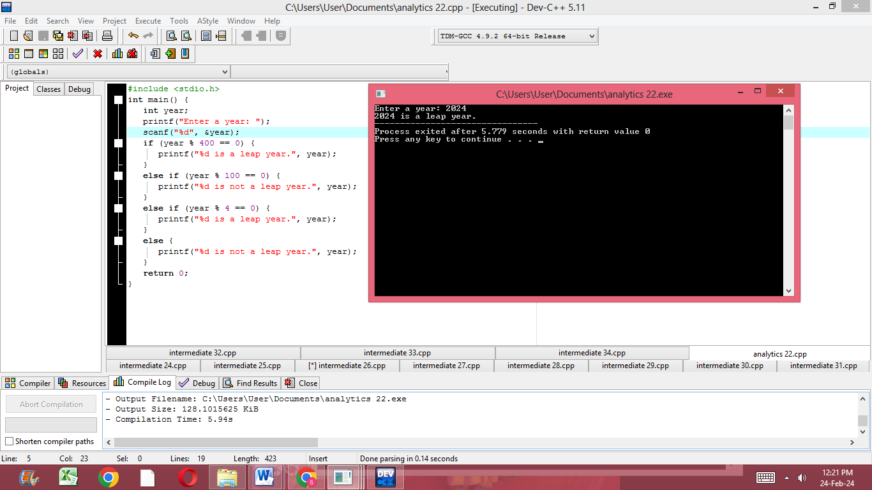

Write a C program to implement a function that calculates the factorial of a given number using recursion.

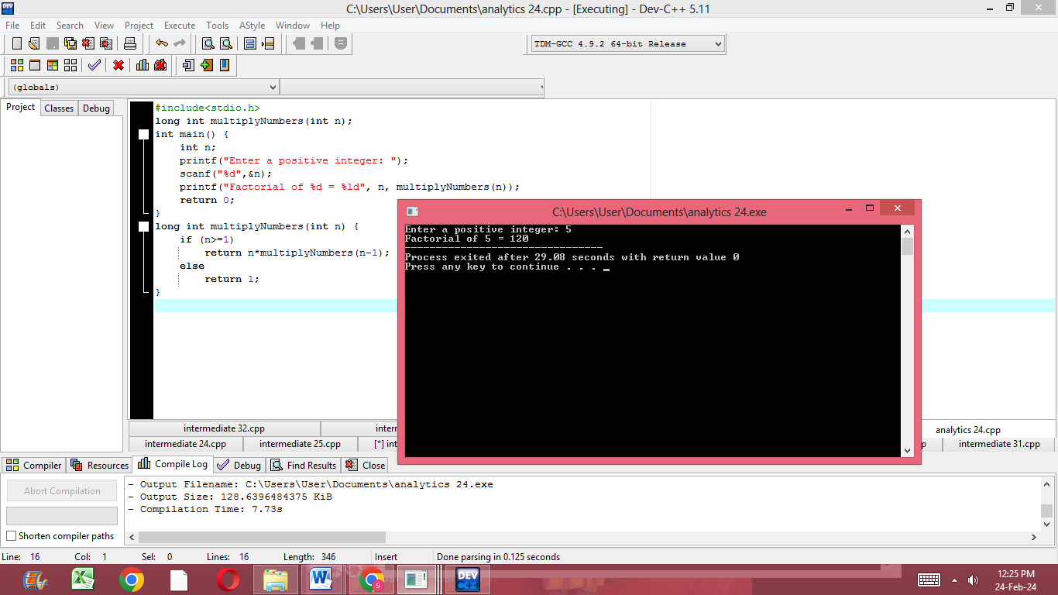

Write a C program to implement a function that checks whether a given number is a palindrome or not without converting it to a string.

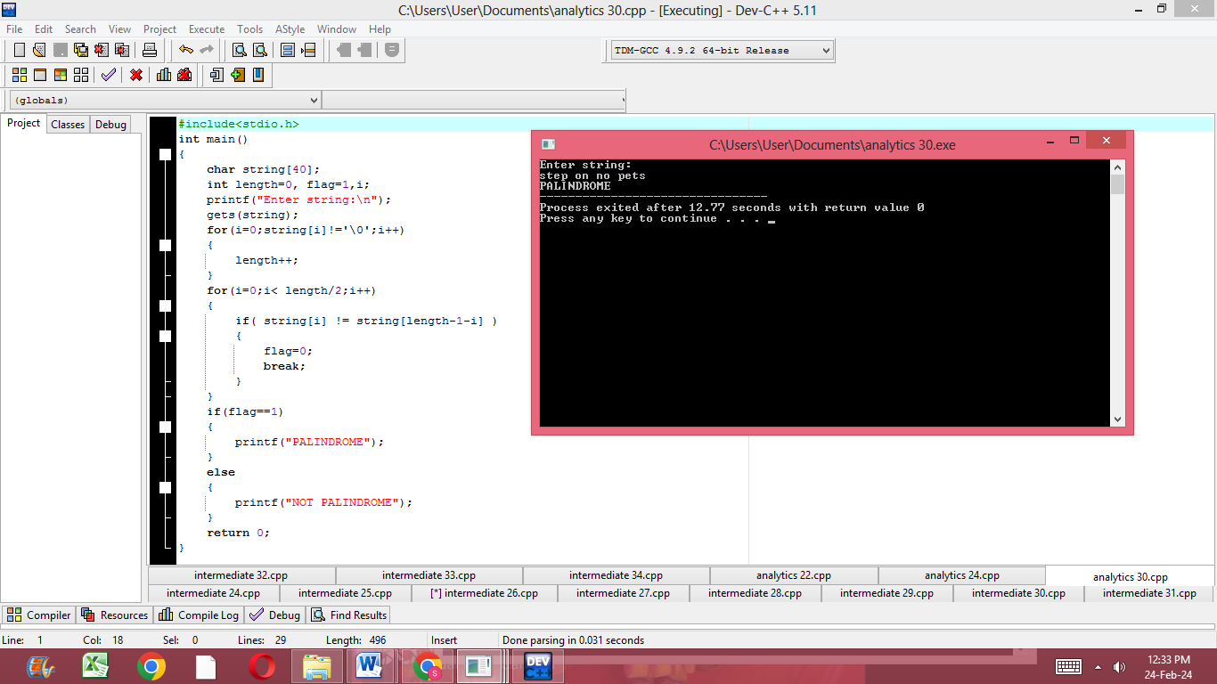

Write a C program to implement a function that checks whether a given string is a valid email address or not**.**

